**VIDEO: PLO > Low Stakes > Multi-Way Equity**

Assumptions: BTN vs. CO

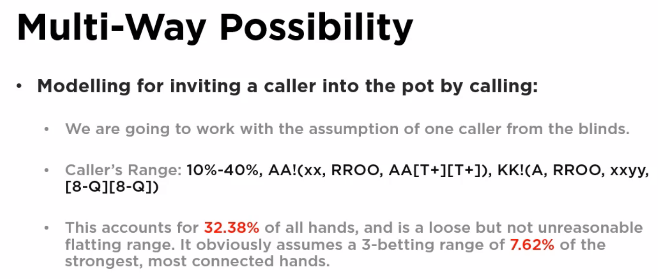

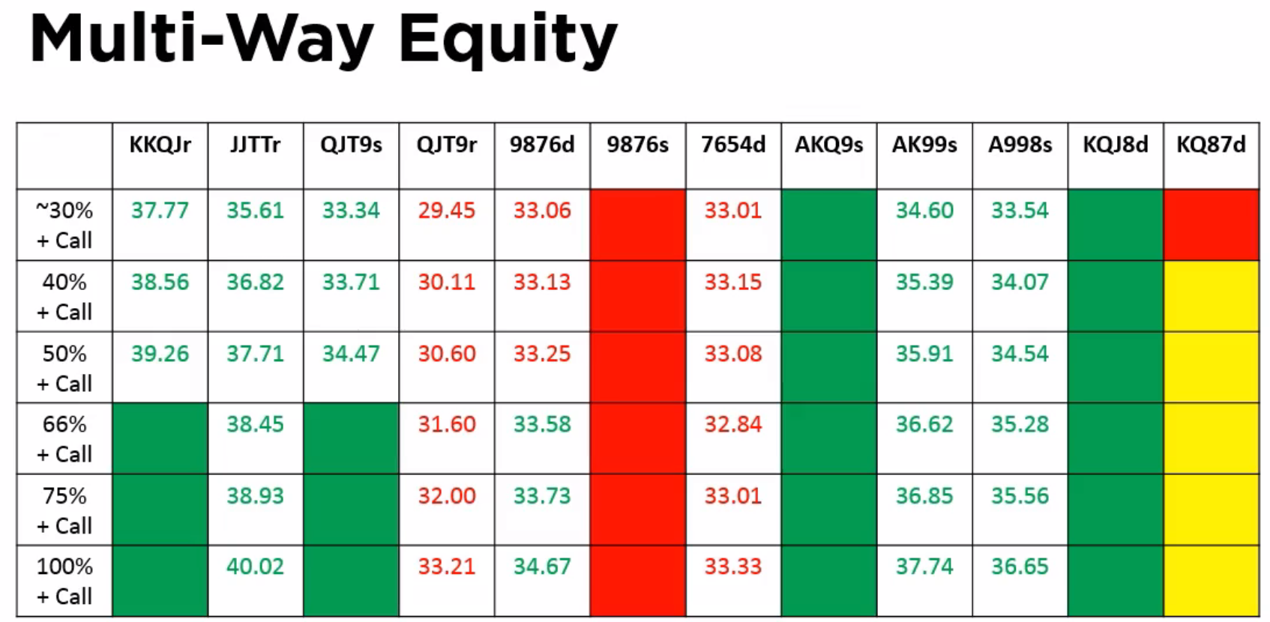

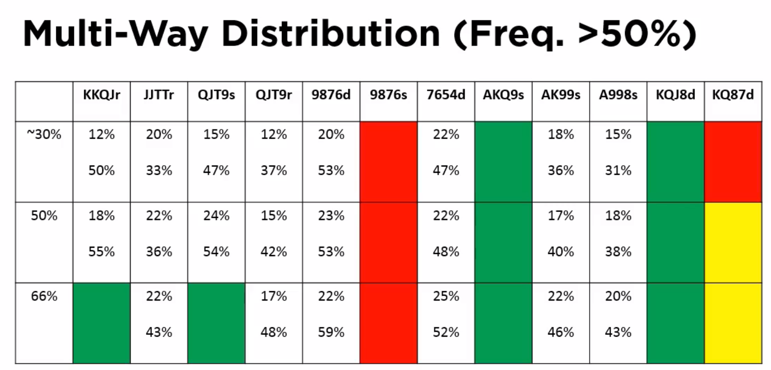

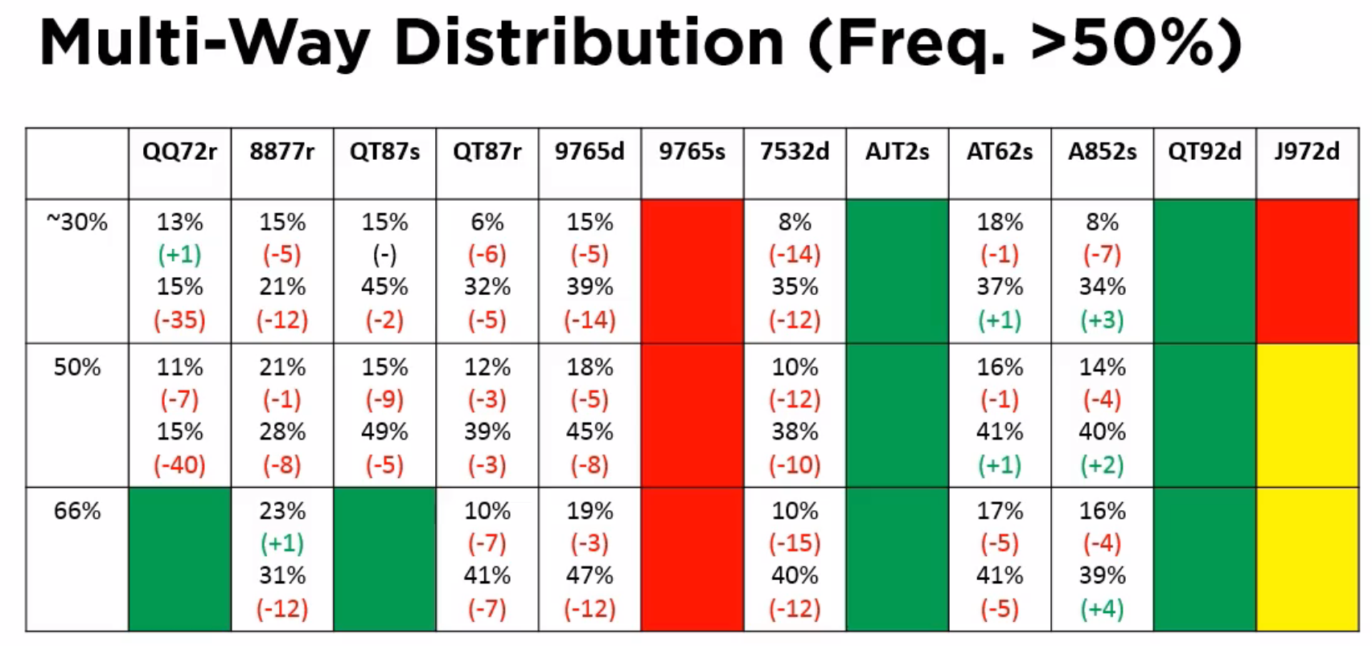

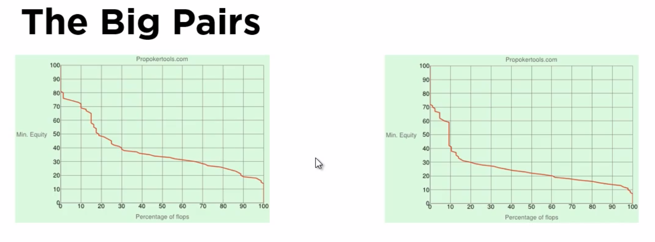

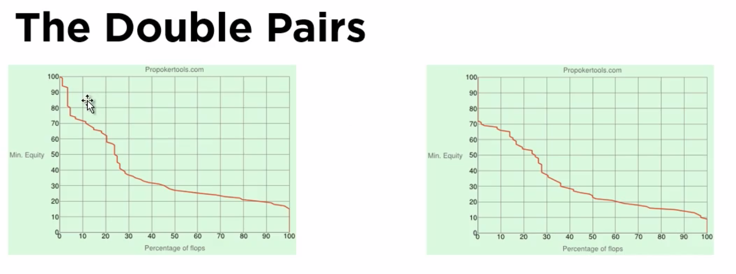

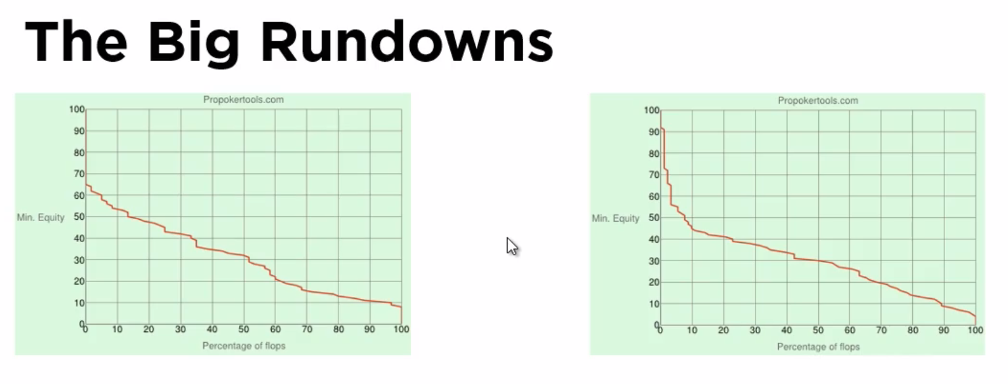

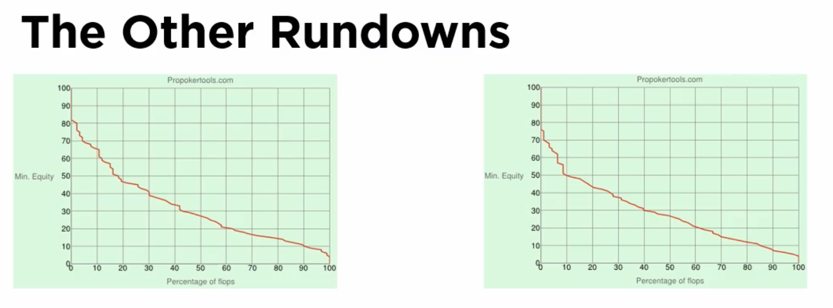

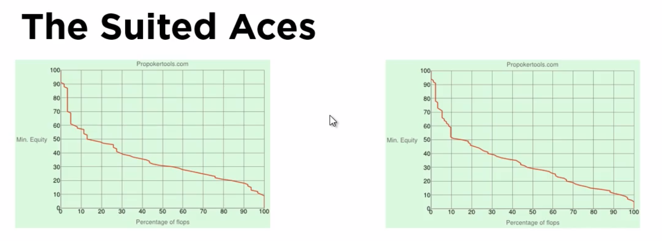

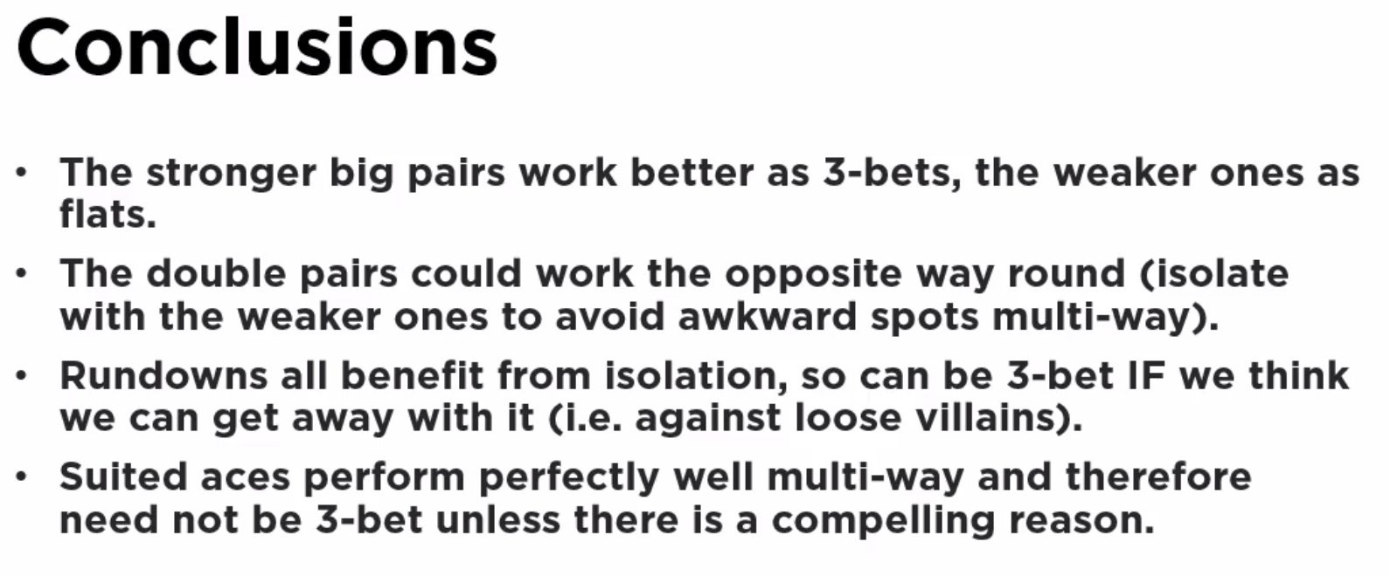

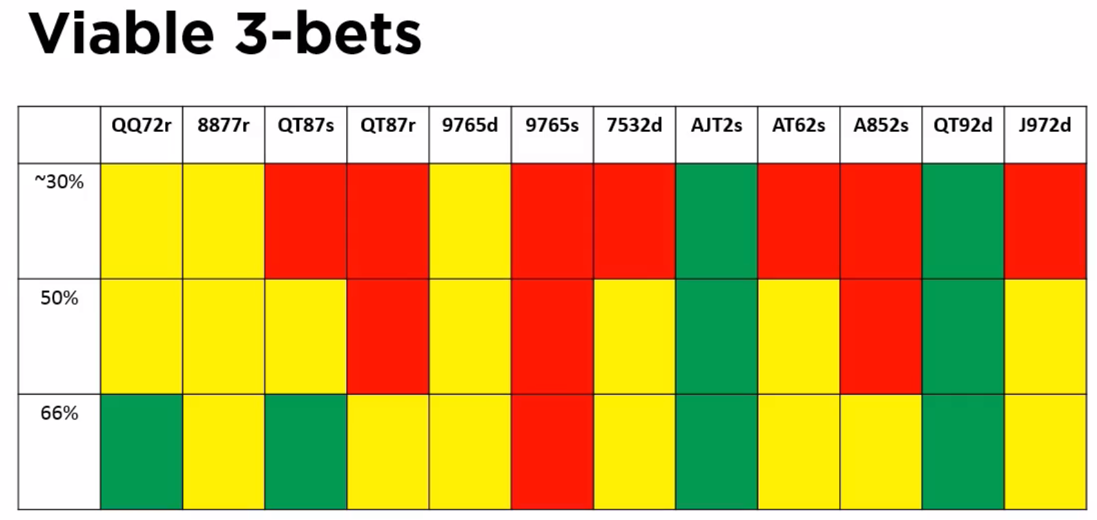

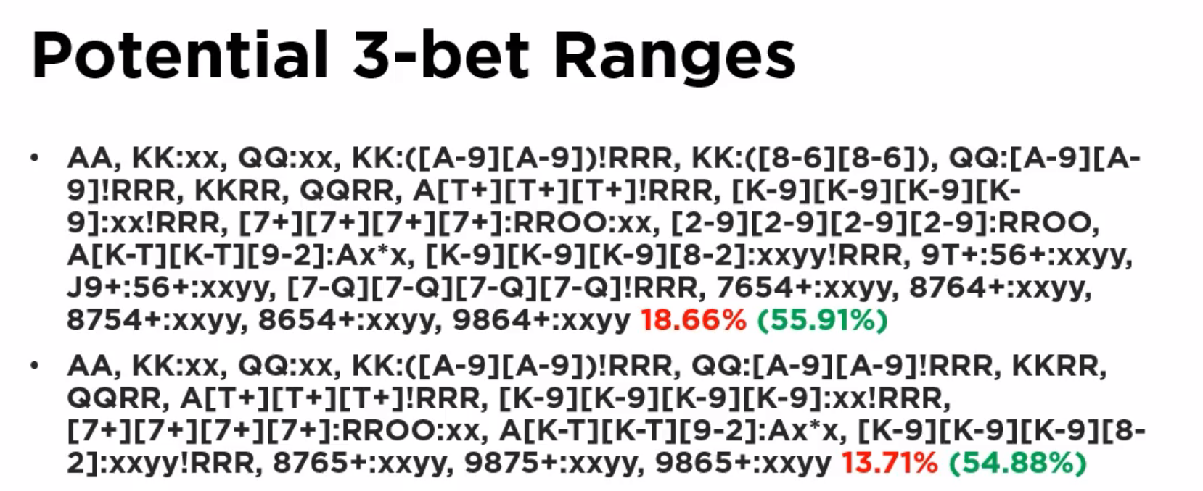

@9min in (multi-way dist (Freq > 50%)

above 50%, above 33%

* mainly want above 50%, rather not have many in 30% -- 50% range
* therefore, hands with a large gap in the two number wont perform well in multiway pots (b/c of sharp fall off in the equity distribution)
* Big pair category showing evidence of large differences between the top and bottom of that particular hand category range
* The rundowns don’t see as much differences across the intra-category range
* Big pair equity dist graph: L=KKQJ vs. 30% range, R=QQ72 vs. 30%
  + QQxx hand shows that it generally either hits a set or nothing
    - But this means they’ll be easy to play
    - Suggests should not be 3-bet
  + KKQJ has a more robust distribution
    - Should be 3-bet b/c we want to avoid a multi-way situation which might be tricky
* Double-pair hands L=JJTT vs. 30%, R=8877
  + Bigger pair has a higher intercept
  + Shallower gradient for the smaller pair (b/c more vulnerable)
  + Should 3-bet smaller/weaker double-pairs ???
    - Don’t push equity edge HU, should get enough c-bets through to make it ok
  + Should play bigger double-pairs multiway ???
    - They should work ok in multiway pots
  + On boards that we miss, both will perform well when we miss
  + But JJTT outperforms
* Big Rundowns
  + L/R = Q-high rundowns
  + Very similar profiles;
    - Both have some equity (a little but not a lot), so you’ll be struggling more to play these hands
    - Will be less sure of the hand when you lop a bit of “something”
  + Given the opportunity we’d like to 3-bet
* Lower rundowns
  + Here these include double-suited (the big rundowns only included single-suited and rainbows)
  + Benefit from isolation
* Suited Aces
  + Peaked, but then slow decline in equity (which can be troubling)
  + … but Tom isn’t much concerned about the profile b/c the flush draw is generally the nut-flush, so it is easy to play
  + Works well multiway; not benefiting from multiway (on average)
    - Makes sense to 3-bet the better hands to push an edge
* Conclusions
  + Diagram excludes the super-premium 4-bettable hands
  + Double-suited rundowns could be marked green (9765d column)
  + Double-pairs (3-bet weaker and
* Ranges
  + Top vs. guy opening vs. 60%
  + Bottom vs. guy opening the custom 32.8% range
  + TAKE SECOND IMAGE B/C HE CORRECTED ON THE FLY